The Elemental Swordsman
GDD Version 1.0
6/3/2025

James Colley

Table of Contents

1.1 High Concept
1.2 Executive Summary
1.3 Key Features
1.4 Genre
1.5 Target Audience
1.6 Platform
1.7 Setting
2.0 Story
2.1 Backstory
2.2 Synopsis
3.0 Gameplay Overview
4.0 Player Controlled Character Overview
4.1 Characters and Abilities
4.2 Character Attributes
4.3 Control Scheme
5.0 Camera
5.1 HUD Overview
5.2 UI Overview
6.0 Combat Overview
6.1 Combat Mechanics
6.2 Spells
6.3 Spell interactions with the environment
6.4 Basic Enemies
6.5 Enemy Attributes
7.0 Level Design Overview
7.1 Zones
7.2 Initial Hubworld Map Layout
8.0 NPCs
8.1 Main Story NPCs
8.2 Side Quest NPCs

1.1 High Concept
The Elemental Swordsman is a top-down hack and slash for PC and Consoles that uses a combo system to cast magic and take on different enemies. Players must intelligently use their spells to take on various monsters and explore the world.

1.2 Executive Summary
The Elemental Swordsman is a top-down hack and slash game that uses combos in order to cast different magical spells. These magical spells will interact with the world and allow the player to target certain monsters’ weak points and solve the puzzles that each elemental zone provides in order to progress.

1.3 Key Features (or Pillars)
- Hack and slash combat
- Magical spells
- Interactive map design that uses the magical spells you learn to block off progression.
- Unique enemies of different elements that interact with your spells.

1.4 Genre
The genre of this game is Pixel Art fantasy hack and slash with a medieval. Being able to cast magic will combine with hacking and slashing in order to produce a unique fusion of the swords man and spellcasting archetypes for character.

1.5 Platform
PC

1.6 Art Style
The art style of this game is an isometric pixel art view similar to The Legend of Zelda: A Link to the Past. Characters will be animated in 4 directions with simple animations for each character’s attacks.

1.7 Setting
The setting takes place in the world of Algravia Land of the Red Pandas which becomes sundered by the elemental lords and turns into battle field between your kingdom’s armies and the void creatures that spawn from void tears. Each of the void tears has altered the fundamental landscape of each region and caused their climate to become extreme and develop according to the Elemental lord of each region. Once the Player defeats all of the elemental Lords, they will be able to enter into the void domain which is a twisted mirror of the kingdom which they need to journey though, place the elemental cores that you receive from defeating the four elemental lords, and eventually the castle where you need to defeat the Terror of the Void.
2.0 Story

2.1 Backstory
I’d like to believe my had a sense of humor when she named me Moon. I was born on the day of a solar eclipse. That was also the day that our Nightmare began. As my first cries echoed out into the world the void split open and the Elemental Lords appeared, their armies of void spawn in tow. When the first hordes came, we our first line of defense fell, caught unawares by the sudden army at our doorstep. We lost the outer reaches of our kingdom in a week. By the time my father organized proper armies it was almost too late. His four generals pushed out with their armies to destroy the Lords. After months of conquest, they finally managed sight the Elemental lords, when a terrible crack rang through the world. At the heart of our kingdom a Fifth void tear started to open. My mother, a mage of awesome might, was the only one powerful enough to hold back his advance, but he was too powerful and continued to break free of the void. Her only choice left was to cast the ultimate seal, gathering traces of the elements, she used herself as the binding to seal the void. Distraught, the king returned to the capital, too heartbroken to lead the war effort. 18 Years later, the armies have been locked in a perpetual war with the void beings. My father has trained me into his ultimate weapon, and with his training I am supposed to beat the elemental lords.

2.2 Story Synopsis
On Moon’s 18th birthday, the seal has again started to crack, with your fathers training you set out to defeat the Elemental Lords before the void opens and lets the Terror of the Void through. Exiting the city in any direction will have a path that when followed will lead to one of the 4 armies where you will be led to talk to one of the Kings Four Generals before you enter each elemental lord’s territory. Over the years, the army has managed to find ways to deal with the void beings. Each General has mastered one of the 4 elements to counter each of the Elemental Lords and will teach the player the spell for that element. When the player learns an element, the seal will start to crack again sending the realm’s magic into chaos and causing the Four Generals retreat to the castle to try and reinforce the seal. Before they leave the General will tell you that you need to take the elemental core from each of the Elemental lords so that they can seal away the Terror of the Void. Entry hazards will spawn all over the map that can only be cleared with their elemental weakness. In order to learn the next element, the player will need to defeat each elemental lord locking them into a progression path based on which element they learned first. After defeating each elemental lord, you return with the Elemental cores. The Terror of the Void’s head is the only part of its body that is currently poking through the void and the player, must drive it back by defeating it. Once it is defeated it retreats into the void, and the soul of your mother appears, she tells you that the Terror of the void will never stop trying to invade so you need to enter and defeat it, by placing the 4 elemental cores on the points of a grand sealing formation to lock away the Terror of the void. The player must then venture to the corners of the void realm to place the Elemental cores on the corners of the seal. Once the cores are in place the player must defeat the Terror of the Void so its soul can be sealed away.

2.3 Narrative Overview
In The Elemental Swordsman the narrative will play a driving role in the story. It will be a linear story mainly told through narrated cut-scenes that detail the history of the region. Important storyline NPCs such as the King and his Generals will trigger these narrated cutscenes to advance the plot. NPCs will have their own stories on their history in the world, but this will be told entirely through dialogue instead of cutscenes. Throughout the region in the destroyed villages that were overrun the character will find various journals of the villagers who once lived there. These journal entries will be nonessential to the plot; however they will point to secrets in the region for the player to explore such as caches of things that were hidden before the voidlings advanced. These small trinkets can be returned to the people who lost them in the capital for small expositional stories about the advance of the voildlings told through dialogue. This section is to state the mode for the narrative corresponding to major events.

Main Storyline

Opening dialogue/Cutscene – The game will start with Moon Sleeping in bed, being woken up by an NPC soldier saying that voidlings have entered the palace. Once the player exits the room it will start a mini tutorial about how to fight, and introduces the player to the threat of the voidlings

King’s Dialogue – The King will serve as a central NPC that will direct the player to where they need to go in the story, as well as providing background details for the backstory of the world. Information about where to go or what you were doing last can be learned by talking to the king

Generals’ Dialogue – The beginning of the game is where the player will have the most agency. The generals will provide immediately knowledge of the Bosses that you will need to face in their respective regions, and what element they learned to hold them back. After learning about each of the bosses the player can then choose to learn one of the elements from the General. After this choice has been made it will lock the player into a progression path that is locked behind learning a new element, by defeating the respective Boss. Other than this branch at the beginning of the game, there will be no other storyline branching.

Boss Cutscenes – Upon encountering a boss there will be a cutscene that plays to introduce the boss for the region. Upon beating the boss, a cutscene will play that details all the changes that will happen to the world. i.e. seals breaking, or environmental hazards being put up in other regions.

Backstory

Opening Cutscene - This cutscene will be the major exposition starting off the game narrating a minor exposition about how the voidlings ended up in this world. He has been raised by this world so he has been made painfully aware of how his world’s situation came to be.

King’s Cutscenes – Throughout the game the King will be a required NPC to talk to and throughout the game the King will expose more and more of the story of the fall of the outer reaches of the kingdom.

NPC Generals’ cutscenes. Before the player can learn an element to use, they will need to talk to the Kingdom’s Generals. Each of these Generals will have a Cutscene detailing a shadowy version of the Elemental Lord that they fought when the gates first opened. These cutscenes will serve as basic introductions to each of the regions that the Bosses have taken over as well as hinting at the way that you need to beat each boss.

NPC Dialogue. Throughout Moon’s journey he can talk to a lot of NPCs, each of these NPCs will have their own sort of trauma concerning the advancement of the voidlings. Some will offer helpful in world tips about how to beat enemies, and others will be purely for adding flavor to the world’s background. Some NPCs will request items that they lost during the invasion, but they have been too scared to retrieve by themselves.

Journal entries comic style cutscenes. As Moon explores the world he will come unto ruins of villages that were left behind during the opening of the gates. These journals will provide first-hand experience of the invasion that will be presented as a comic style flash cuts of soldiers fighting off the invaders. Some of these journals will be from non-combatants, and these journals will contain clues to hidden secrets in the world or trinkets that people left behind during the invasion. Returning these items to people will complete side-quests and will lead to more world exposition for the player.

3.0 Gameplay Overview
The player will be able to explore the world and the world will gradually open up as you learn more magic. Quests can be completed throughout each zone, with some spanning multiple zones as you progress their storylines. Players will need to navigate the world using magic as a means to counter each of the elemental areas. The core of this gameplay is the combat system, player can use the light(RT/J) and heavy attacks(LT/K) to slash their foes to ribbons with a 1-2-3 combo from both combo lines. After pressing 2 attacks you can prep a spell element by pressing RB/L and unleash a spell by finishing the combo.

3.1 Spell Properties:
Fire: Will burn the ground do chips of damage to enemies and melt metal enemies, water elementals walking over fire will douse the flames.

Water: Will push enemies away and leave puddles on the ground that will slow enemy walking speed. Lightning attacks will affect all enemies standing on water, fire enemies will slowly dry the puddles.

Lightning: Wil jump to nearby enemies to cause damage, any enemy standing on water will be electrocuted, is attracted to metal enemies, and will not damage them.

Metal: Will create metal objects that the player can hid behind and initially pop out with damage. Electric attacks are redirected to hitting the metal object and will not deal damage. Fire attacks will melt the metal in one hit. The created metal object will despawn when it takes too much damage.

Secondary mechanics: This game will have progression blocked, by which spells you have unlocked and will force the player down a specific path because their spell helps them clear the way forward. Fire spells will be able to melt certain walls and items on the map so that the player can bypass them. Water will douse fire that block your path. Metal will redirect electrical currents so that you can connect circuits that force components of the world to move. Lightning will let you shock bodies of water so that you can charge switches without an existing electrical current. Each of these mechanics is designed for puzzles and trap that the player will need to navigate carefully.

4.0 Player Controlled Characters Overview
The main character Moon, was born on the day of a solar eclipse, Moon is the only son the King. He has been raised by the king as a fearsome warrior to combat the threat of the Void spawn. His skills with the sword are unmatched within the kingdom. Trained to be the savior of his people Moon strives to live up to their expectations and sets out on his Quest to defeat the Terror of the Void.

  - General Controls
The player will have a relatively limited control scheme to control moon. Movement will be controlled by the left stick or arrow keys being able to walk in any direction the player chooses. The player will be able to interact with NPCs by walking up to them and pressing A on controller and F on Keyboard. The primary mode of interaction with the world will be the attack functions which are RT/LT on controller and J/K on keyboard

  - Attacks
Combat is designed to be in a top down format in 4 directions: Moon has two series of attack combos: Light attacks, and Heavy attacks. These attacks can be used interchangeably during a combo i.e. Light 1-> Light 2 -> Light 3 as the full light string combo, Light 1-> Heavy 2-> Light 3, or Light 1-> Heavy 2-> Heavy 3 would be an interchangeable combo. After the second attack in a string, the player can prepare a Spell by pressing the Right Bumper. The first two attacks in a combo will decide which type of spell that you can cast, and pressing the Right Bumper will choose the element of the spell based off of the first two button presses. Completing the combo by pressing Light 3 or Heavy 3 will perform the last move in the combo augmented by your selected elemental spell.

Light 1: A quick horizontal slash that moves the player forwards half a grid square.
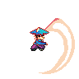
Light 2: A quick downwards slash that moves the player forwards half a grid square.
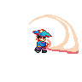
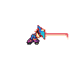
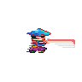
Light 3: A quick lunging attack that moves the player forwards a full grid square and pushes enemy units to the side.

Heavy 1: A long charging slashing attack launches the player forwards 3 grid squares and pushes enemy units to the side.
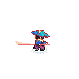
Heavy 2: A highly controllable aerial summersault that allows the player to move up to 4 grid squares in any direction and pushes enemies in any direction away from the player.
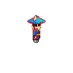
Heavy 3: A control able whirlwind of death that allows the player to move up to 6 grid squares in any direction and pushes the enemies away from the player.



4.3 Spells

Fire Elemental Mastery:

Combo Start: Light 1-> Heavy 2

Light Variation: The player will launch a fireball straight ahead of them that explodes, and leaves behind a patch of burning ground that will hurt enemies that walk over it.

Heavy Variation: The player will ignite their sword leaving behind a large trail of burning ground that lasts a lot longer than the light variations.

Water Elemental Mastery:

Combo Start: Heavy 1 -> Light 2

Light Variation: The player will launch a watery ball straight ahead of them that explodes, and leaves behind a patch of water that will slow enemies that walk over it. All enemies standing on water will take lightning damage if a lightning spell is cast on the water.

Heavy Variation: The player will freeze their sword leaving behind a large trail of water on ground that lasts a lot longer than the light variations and freezes all enemies that are hit initially.

Lightning Elemental Mastery:

Combo Start: Light 1 -> Light 2

Light Variation: The player will launch a slow-moving lightning ball straight ahead of them that shocks the enemies that it passes through. Shock will try to pass to a nearby enemy after it has ended. If an enemy gets shocked while standing on water, all other enemies standing on water will be shocked as well.

Heavy Variation: The player will electrify their sword shocking any enemy that they pass through.

Metal Elemental Mastery:

Combo Start: Heavy 1 - > Heavy 2

Light Variation: The player will spawn a small metal spike in front of them. The metal spike will act as creatable terrain that attracts lightning attacks from enemies

Heavy Variation: The player will spawn a trail of large spikes that burst from the ground and deal damage.
4.3 Control Scheme

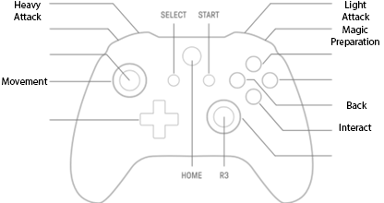

The Controller scheme for The Elemental Swordsmans is a very simple control scheme. Designed primarily to work with console controllers, the scheme is very basic. The A button will be the basic interact function letting the player obtain information about the work or talk with NPCs by pressing A near points of interest. The B button will primarily work in menus allowing the player to go back. The Light attacks and the Heavy attacks will be preformed by pressing the LT and RT buttons each of which will allow the player to attack. The Right Bumper will be the Magic Preparation button that allows the player to ready their next magical cast.
Start/P | Pauses the game
A/F | Interacts with the world i.e. Talks to people
B/G | Back button
R2/K | Light attack
L2/J | Heavy attack
R1/L | Magic Preparation

5.0 Camera and HUD

5.0 Camera
The Elemental Swordsman uses a Top-down perspective with an Area locked camera in order to flow the player during intense hack and slash gameplay. The camera will stay locked onto the player for the majority of the time, only shifting when the player approaches the bounds of the playable zone. Shifting into a new Area will set and pan the Camera over to a new set of bounds. Dialogue and interacting with Shopkeepers will freeze and darken the game world and the camera will project the characters interacting in the foreground of the camera, to try and imitate the feel of a JRPG.
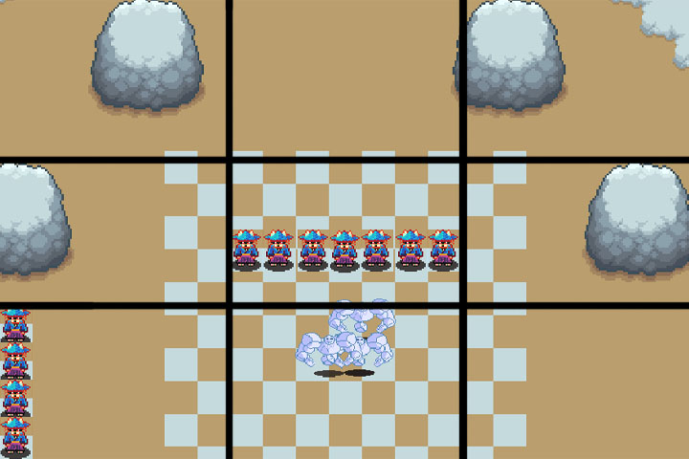
5.1 Camera Diagram:

The Camera is from a top-down perspective with the camera locked onto the player in the middle of the screen. The camera perspective has the player at 1/12 the height of the screen and 1/21 of the screen width this provides the player with a large field of view to observe oncoming enemies and the environment. With proper foresight players should be able plan out their movements in advance to take advantage of their oncoming terrain. The camera will lock to edges of an area and will follow the player when they are inside the bounds. The camera will define new bounds when the player exits the bounds of one zone and enters a new area or loads a new scene. Enemies are activated when the camera enters their area, and are deactivated when the camera leaves their area. Enemies are respawned when the player either does not visit that camera area for 10 minutes, the player has died, or if a new scene has been loaded.

5.2 HUD User Interface
The top left part of the screen shows the relevant player information denoting health and each elements spell cooldown. Each spell will have their own unique symbol that fills in radially to denote when the spell has come off of cooldown. These HUD elements as well at the mini-map will be comprised of non-diegetic HUD element place around the edge of the screen. Enemy health bars will only show themselves briefly when an enemy takes damage and will hide themselves after the player hasn’t damaged the enemy for 15 seconds. The enemy healthbars will be spatial elements. The mini-map comprises the bottom right portion of the screen and it give the player a rough outline of the immediate area twice the size of the player’s vision as well as informing the player of incoming enemies before they enter the players screen.

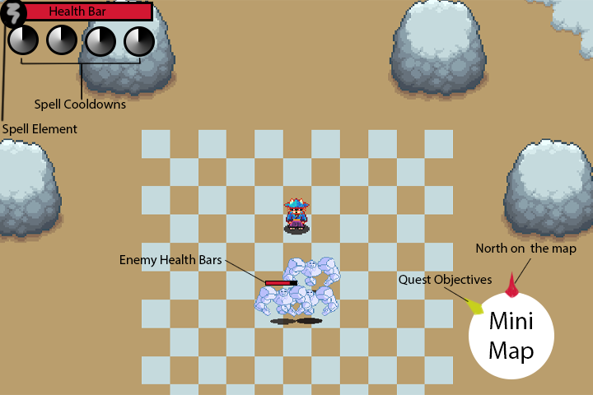
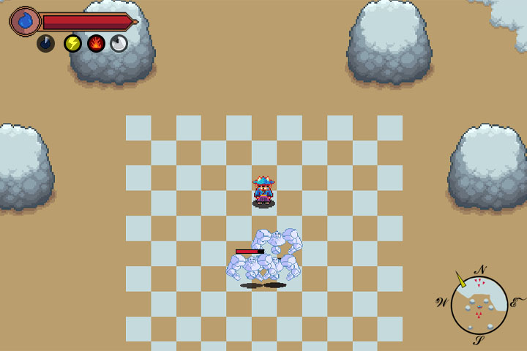
Mini-Map: The mini-map display will show the player the immediate area twice the size of the player’s visible range. The incoming enemies will only be shown as red triangles as they approach the player. It will show quest objectives with a yellow arrow pointing in the general direction of the objective. Multiple objectives can be displayed at any given time.

Player Health: The player health will display the players current health and will flash red when taking damage and green when healing.

Enemy Health Bars: Enemy health bars will only display above the enemies for a short time after there are damaged. After 15 seconds the enemy health bar will revert to being invisible to the player. When the player encounters a Boss arena, a large enemy health bar will appear at the bottom of the screen with the Boss’s name written on top.

Spell Cooldown: As the player advances through the game, elemental symbols will appear beneath the player’s health bar corresponding to each of the elements that they master. Each element will have its own individual cooldown that will be visibly managed by the HUD.

Spell Selection: The player will constantly be fighting so the spells that are based off of the combo system will constantly change. The Spell selection is designed to help the player keep track of which spell element will be imbued into their next magical cast.
6.0 Combat System Overview
The combat system of The Elemental Swordsman at its heart will consist of a series of 7 interlaced attacks that form the basis of a combo system. The primary focus of this combat system will be a quick moving melee. As there is no blocking, each attack will move the character in the direction the player’s character was already moving allowing the character rapidly move around on the battlefield. There are two 3 hit-primary combo strings that can be performed, the Light Attack String and the Heavy Attack String. The Light attacks are designed to rapidly whittle down enemy health points. These strikes are a quickly performed combo that provide basic hack and slash capabilities. It consists of a quick horizontal slash, a downward slash, finished by a lunging attack. The Heavy attacks are slow hard-hitting strikes designed let the player move large distances. The first strike in the heavy combo is an attack that charges up and then launches the player in their chosen direction. The second strike is an aerial summersault that allows the player to freely move in any direction. The final strike is a whirlwind that allows the player to freely move in any direction damaging enemies along the way.

The 3-hit attack strings can be interchanged between the combos by pressing the other attacking button. The resulting move will be the attack in order of the primary combo, i.e. Light 1, Heavy 2, Heavy 3 would be a variation. After the first two attacks of any attack string, the player can use the last move in their arsenal the Infuse attack. The Infuse attack slightly retreats the player in the opposite direction and charges up the player’s next attack with an Elemental Infusion. The first two attacks will decide the element of the Infusion from the table below. Once an element has be chosen the player’s next attack will cast a spell variation based on the Light and Heavy finishing moves. Performing an infused attack will put that element on a cooldown. All enemies can be killed by basic slashes; however, different elemental enemy types will have weaknesses that can be targeted by specific element.

Spell Selection | Light 1 | Heavy 1
Light 2 | Lightning infusion | Fire Infusion
Heavy 2 | Water Infusion | Metal Infusion

6.1 Combat Mechanics
Health: Player themselves will have a maximum of 50 Health points This important stat will be managed with whole numbers so that damage is very obvious to the player and the damage calculations remain simple.

Movement: Beyond being able to just walk around and avoid attacks the basis of this combat system is being able to move your character through creative usage of your combo. Each attack will carry your forwards with the heavy attacks letting you travel a long distance.

Knockback: Knockback will be applied with every attack. The greater the knockback the further a character is launched away from the initial point of impact. In scripting it is a simple apply force function.

Super Armor: Super armor allows the player to take the full damage of an enemy’s attack, without being knocked out of the player’s current attack.
Health pods – Enemies will drop health pods as the player kills them which will allow the player to pick up them up and heal for 5 damage with every health pod.

Attack Values:

 | Light 1 | Light 2 | Light 3 | Heavy 1 | Heavy 2 | Heavy 3
Damage | 3 | 3 | 5 | 6 | 6 | 8
Distance | 1 | 1 | 3 | 3 | 5 | 8
Knockback | 2 | 7 | 7 | 5 | 5 | 10
Can Combo | Yes | Yes |  | Yes | Yes
Super Armor |  |  |  |  | Yes | Yes

6.2 Spells:
Spells can be cast by using the Infuse attack after attacking 2 times. Each elemental type will be managed by its own cooldown and will not take up a secondary resource to use.

Fire Elemental Mastery:

Light Variation – The player will launch a fireball straight ahead of them that explodes dealing 7 damage, and leaves behind a small patch of burning ground that lasts 7 seconds will deal 1 damage to any unit that walks over it.

Heavy Variation – The player will ignite their sword leaving behind a large trail of burning ground that lasts 14 seconds.

Water Elemental Mastery:

Light Variation – The player will launch a watery ball straight ahead of them that explodes dealing 5 damage, and leaves behind a patch of water that lasts 7 seconds slow enemies that walk over it by 30%. All enemies standing on water will take lightning damage if a lightning spell is cast on the water.

Heavy Variation – The player will freeze their sword leaving behind a large trail of water on ground that lasts 12 seconds freezes all enemies that are hit initially.

Lightning Elemental Mastery:

Light Variation – The player will launch a slow-moving lightning ball straight ahead of them that shocks the enemies that it passes through initially dealing 4 damage. Lightning spell will try to chain to a nearby enemy after it has ended dealing 1 less damage for every enemy it has passed through. If an enemy gets shocked while standing on water, all other enemies standing on water will be shocked as well.

Heavy Variation – The player will electrify their sword shocking any enemy that they pass through.

Metal Elemental Mastery:
Light Variation – The player will spawn a small metal spike in front of them dealing 10 damage in the center and 5 damage on the sides. The metal spike will act as creatable terrain that attracts lightning attacks from enemies

Heavy Variation – The player will spawn a trail of large spikes that burst from the ground and deal damage 10 damage.

Spells | Damage | Damage Type | Cooldown | Range | Secondary effect | Enemy Type Resistances:  Fire/Water/Lightning/Metal
Fire – Light Variant | 7 | Fire | 10 | 5 | Burning Ground | Immune/+2/0/-2
Fire – Heavy Variant | 7 | Fire | 15 | Melee | Burning Ground | Immune/+2/0/-2
Water – Light Variant | 5 | Water | 7 | 4 | Water Puddle | -2/Immune/0/+1
Water – Heavy Variant | 5 | Water | 9 | Melee | Water Puddle | -2/Immune/0/+1
Lightning – Light Variant | 4 | Lightning | 10 | 7 | Lightning Chain | 0/-2/0/Immune
Lightning – Heavy Variant | 6 | Lightning | 10 | Melee | Lightning Chain | 0/-2/0/Immune
Metal – Light Variant | 10 | Neutral | 15 | 3 | Metal Pillar | 0/0/Immune/0
Metal – Heavy Variant | 10 | Neutral | 15 | Melee | Metal Pillar | 0/0/Immune/0

Burning ground – Burning ground will affect both the player’s and enemies causing damage whenever it is stood on for at least a second. Each second will cause 1 damage to every unit standing on it. Fire units will be healed instead. Light variant lasts for 7 seconds, heavy variation for 14.

Water Puddle – Water Puddles will slow down every unit that walks over it. If an enemy is standing on a water puddle and is hit with a lightning attack will cause all units also standing on that same puddle to take lightning damage. Light variant lasts for 7 seconds, heavy variant for 12 plus freezing for 2 seconds.

Lightning Chain – Lightning attacks will arc to one nearby units in the vicinity stunning them and dealing 1 less damage for every time the lightning has chained starting from the initial damage.

Metal Pillar - The Metal pillars will absorb any Lightning attack in the vicinity. Lighting will not be able to arc after hitting the metal pillars. Light Variant lasts for 10 seconds. Heavy variant last for 12.

6.3 Spell interactions with the Environment
Environment interactions will be an integral part of the player’s exploration during game play. The player’s progression will depend on which spells they acquire in the course of the game. Each element will be able to affect different objects in the overworld. The different regions of the map will each have a barrier to entry that is blocked off by a world object that can only be removed by casting a spell to destroy the obstacle. Regions will mainly have obstacles related to the spell required to unlock the region, but nonessential areas will be blocked of with obstacles of other regions. These areas could contain quests, mini-bosses, or even secret items.

Fire Spells – These spells are supposed to burn things and spread fire around to clear out large amounts of enemies. For the environment they clear away obstacles and light up areas.

Wood – Any wood can be affected by a fire spell. The wood will burn away and it will deal 1 fire damage to anything that gets into contact with it. This fire can spread to other flammable materials.
Ice – Ice can be melted by fire spells, and it will leave a puddle of water when it melts away.
Torches – Torches can be lit up by fire spells and will be used for a variety of tasks, opening doors, unblocking pathways, time attack, puzzles.

Water Spells – Water spells are supposed to serve as environmental hazards for enemies. They slow enemies when they walk over them, and provide a new avenue for your lightning spells. For the environment they douse fire and let electricity flow.

Fire/Lava – Areas afflicted by fire can be doused with a water spell. Some fiery areas such as lava can only be cooled down temporarily by water and will erupt into fire again after a short delay. Lava that has been hardened can be walked over temporarily.
Electricity Switches – Water spells will leave behind water puddles which can conduct electricity that charge up electricity switches. Switches can do all sorts of functions like opening doors, or lowering bridges.
Torches – Water spells can douse torches which can be used for a variety of tasks, opening doors, unblocking pathways, time attack, puzzles.

Lightning Spells – Lighting spells are your fastest form of spell damage, and will allow you to quickly stun and spread out damage among the enemies. For the environment they power objects.

Water Puddles – Water puddles will conduct electricity from lightning spells. Any affectable entity from enemies to switches will be affected when they are in a puddle of water.
Electricity Switches – Lightning Spells can charge up switches. Switches can do all sorts of functions like opening doors, or lowering bridges
Metal – Metal will act like a lightning rod and will absorb lightning spells.

Metal Spells – Metal Spells are physical in nature and will serve as physical obstacles for the enemies. For the Environment they redirect electrical current.

Lightning projectiles – Metal pillars will attract and negate enemy lightning projectiles
Lightning beams – Lightning beams that lock off certain locations can be redirected by casting metal pillars near them.
Physical switches – Physical switches can only be hit by a metal spells. Switches can do all sorts of functions like opening doors, or lowering bridges

6.4 Basic Enemies
The basic enemies in The Elemental Swordsman are the Voidlings. There are 4 types of Voidling with each different type corresponding to an elemental typing: Lightning, Water, Fire, and Metal. Each of these units will serve their particular niche for enemy. Lightning Voidlings will be fast and mobile ranged units that seeks to dash away from the player as they approach. Fire Voidlings will serve as medium speed ranged units, their fireball attacks will leave burning on the ground. Water Voidlings are medium speed melee units, that will spread water terrain when they attack that will slow the walking speed of the player. Metal Voidlings are very slow melee units that take reduced damage from all attacks, until they take damage from a fire spell which causes them to heat up so that attacks deal more damage. All units will have a series of basic AI states: Patrol, Advance, Retreat, Dodge, and Attack. Advance will move the enemy closer to its chosen direction. Retreat will do the opposite. Dodge will move the enemy perpendicularly to the vector between the unit and the player. Attack can only be triggered by being within a certain range of the player. When units are patrolling the will choose a direction to move in for 1-3 seconds, before choosing another direction to randomly move in. Enemies will be given a basic range that they can move in when they are spawned in. That basic range area will reset to where they are standing if the unit loses track of the player. When the player enters the range of an enemy unit they will immediately attempt to move close enough to the player with Advance. Once close enough, the Voidlings will be able choose any of the basic AI states as an option. Each elemental will be completely immune to their own element when hit by the player’s spell.

Lightning Voidling

Description: The Lightning Voidling is a fast ranged unit. It looks like a flying ball of sparks that is constantly spewing out electricity. These units prefer to remain on the periphery of the screen trying to fire at the player from a distance. When approached by the player these enemies will prioritize escaping and will use their fast movement speed to either dodge or retreat. After they retreat or dodge away from the player they will seek to attack the player with ranged lightning. These units will act as sentry units and will call over other enemy units if they are not defeated swiftly.
Health: 18
Attack Description: Long Range. The Lightning Voidling will briefly charge up sparking more intensely before launching a quick moving projectile in the player’s direction that will deal 1 damage and stun the player.
Speed: Very Fast
Special Trait: Extended dodge. These units will have double their normal speed when dodging or retreating.
Weakness: Metal spells will leave a lingering spike field that will force all Lightning Voidlings’ attacks to shoot towards the lingering spike instead of where they were originally aimed. The enemies retreat and dodge will only happen if the player slowly approaches them, using the heavy strikes will hit the lightning voidlings fast enough so that they can’t dodge or retreat away from the player.
Fire Voidling

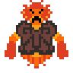
Description: The Fire Voidling is a medium size unit that looks like a flames within a suit of armor. These units will try to stay at a medium range to the player. These units will have an even chance to attack the player or dodge/retreat when the player approaches them. If a Fire Voidling stands long enough on a flammable surface that surface can catch fire and deal damage to the player.
Health: 24
Attack Description: Medium ranged attack. The Fire voidling will flare up before launching a slow-moving projectile that will explode after a short distance. The explosion AOE will deal 4 damage and leave behind a small area of burning ground that lasts for 7 seconds that deals 1 damage to the player for every second that they stand on the burning ground.
Speed: Medium
Special Trait: Burning soul. While a Fire Voidling is standing over burning ground, they will recover 1 heal point every second.
Weakness: Water spells will deal more damage to this unit and standing over the water puddles left behind by the water spells will deal 1 damage to this unit every second that they are standing over it.

Water Voidling

Description: The Water Voidling is a medium size unit that looks like floating orbs of water. This unit will seek to get into medium range of the enemy player before launching an attack. This unit will have an equal chance to attack dodge or approach the player once they are in range. Their attacks will leave behind water puddles that will slow all units besides water units.
Health: 30
Attack Description: Melee range. The water Voidling will swell up like bubble then pop itself to deal 5 damage in an AOE and leave behind a puddle that will slow all units that walk over it
Speed: Slow
Special Trait: Healing Waters. Every 2 seconds that they are not damaged, these units will heal 3 health.
Weakness: Lightning spells will deal double damage to these units and will stun them for 3 full seconds.
Metal Voidling
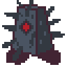
Description: The Metal Voidling is a large lumbering unit that looks like a sentient block of spikey metal. This unit once aggroed will prioritize getting close to the player instead of retreating or dodging and cannot be stunned by the players attacks. When hit directly by a fire attack, or standing long enough on a burning surface, the Metal Voidling will heat up and glow cherry red for 10 seconds. During that time the player will deal full damage to the Metal Voidling instead of just one.
Health: 25
Attack Description: Melee range. The Metal Voidlings’ attack will be a close-range ground slam with a long wind up that spawns spikes all around the Voidling dealing 7 damage to the player.
Speed: Very Slow
Special Trait: Iron Skin allows Metal Voidlings to reduce any damage taken to 1.
Weakness: Fire spells will deal more damage to this unit and will heat up the metal for 10 seconds allowing the player to deal full damage to this unit.

6.5 Enemy Attributes
Health – The Enemies health before there are destroyed
Speed – The Speed that the enemies have in relation to the player’s speed
Attack Damage – The damage cause by the initial attack of the Enemy
Resistances – The types of damage that enemies are resistant to.
Weakness – The type of damage that the enemy is weak to.

Enemy Unit | Health | Speed | Attack Damage | Resistances | Weakness
Lightning Voidling | 18 | Very fast | 1 | Lightning | Metal
Fire Voidling | 24 | Medium | 4 | Fire | Water
Water Voidling | 30 | Slow | 5 | Water | Lightning
Metal Voidling | 25 | Very Slow | 7 | All (until Iron Skin has been melted) | Fire

7.0 Level Design Overview

Overview - Level design in the Elemental Swordsman will consist 2D tilesets. The layout for the majority of the game needs to be designed with the player’s attacking movement in mind. A few of the player’s attack travel long distances so layout for areas in which enemies can spawn needs to be wide enough for the player to properly maneuver and not feel like the environment is getting in the way. Puzzles that require spells to solve should focus on teaching the player the limits of what they can do with spell casting and the movement of those attacks. Barriers that are required to be broken by certain spells should be very simple without the complexity of puzzle. There will be 6 different tile sets. One for each zone which will correspond to the coloring of each element with the wild zone being an overall neutral green.

7.1 Zones
Hub World – The central hub world that the player starts in will be the walled off castle town. This is where the player will be able to interact with mainline story NPCs and start numerous sidequests that will take them all around the region. The center of the town will be the castle where the player can interact with the King and Generals. The outer houses will hold various NPCs that give the player context to the world and will set the player off on sidequests to unlock more story or benefit from the town. There will be 4 main exits from the town at the north, south, east, and west respectively. These will exit to the kingdom’s last ring of defense outside of the walls called the Wild Zone. The player will be forced to fight to the edge of the Wild Zone in order to find one of the entrances to the Elemental Zones.

Wild Zone – Wild zone is the transitory area from castle town to the Elemental zones. Enemies will constantly spawn in to attack the player. Enemies of all types can spawn in the zone, but heading in the direction of one of the Elemental Zones will skew the enemies to correspond more closely to that type. This area will be sprinkled intermittently with soldiers that can help the player fight. The Wild Zone will have 4 main paths, one to each of the gates, there will be sideways progression through the wild zone, to other gates, but certain pathways can be blocked off by barriers that need to be destroyed by specific elemental type spells. All puzzles in the wild zone will consist of 2 or more elements, so that players need to back track after gaining a new element. After solving the puzzle this will open up a mini dungeon for the player.

Metal Zone – The metal zone will be located in the North. This zone will be a mountainous region that will require the Fire element to solve. The trees have overgrown the path and need to be burned, away, and unlit torches will be the primary puzzles in this area.

Fire Zone – The Fire zone will be located in the West. This zone will be another mountainous region that requires the Water element to solve. Players will need to navigate over fire and lava to traverse this zone. Torches that need to be doused in this area will be the primate puzzles in this area.

Water Zone – The Water zone will be located in the East. This zone is going to be a lake region that requires the Lightning element to be solve. This area will consist of a small bunch of islands that the player will need to navigate around. Being able to power up various switches with lightning spells will be the main puzzle in this area.

Lightning Zone – The Lightning zone will be located in the South. This zone is going to be a dry desert region that requires the Metal element to solve. This area should feel like a lost civilization that is still sparking with electricity. The electricity needs to be redirected by the metal pillars and will be the main puzzles in this area.

7.2 Initial Hubworld Map Layout

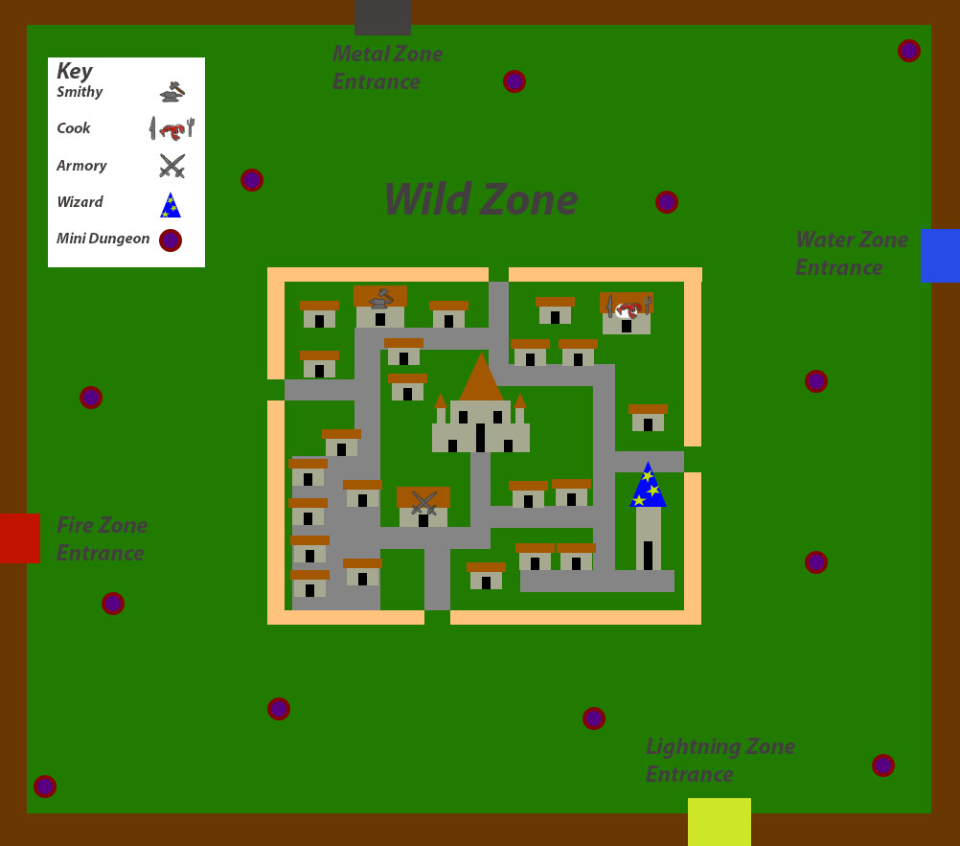

8.0 NPCs

8.1 Story NPCs

The King – The King plays a central role in story by directing the player with cutscenes and dialogue.

The Queen – The Queen is an NPC that you will meet much later in the story when the player has finally defeated the Elemental Lords.

The Generals – The Generals are the NPCs that will teach the player their first spell and they will decide your progression path in the game.

8.2 Sidequest NPCs

In this game Sidequest NPCs will play a role in the player’s progression

Smithy – The smithy will offer you a sidequest to find 3 elemental minerals in each region. By finding each elemental mineral the player can upgrade their sword to deal more basic damage to a certain element of enemy.

Chef – The Chef will offer you meals if you can if the ingredients for his recipes. Each of Chefs meals will increase the total HP of the player permanently, Chef’s ingredients can only be found in mini dungeons.

Quarter Master – The quarter master will task you with finding missing soldiers. For every missing soldier that you recover, the number of enemies that spawn in the Wild Zone will lessen. The soldiers can be found both in the Wild Zone and the elemental regions.

The Wizard – The Wizard will task the player with killing a certain amount of Voidlings. For killing enough Voidlings of an elemental type, the wizard will increase the damage of that type of spell.

